FOR IMMEDIATE RELEASE
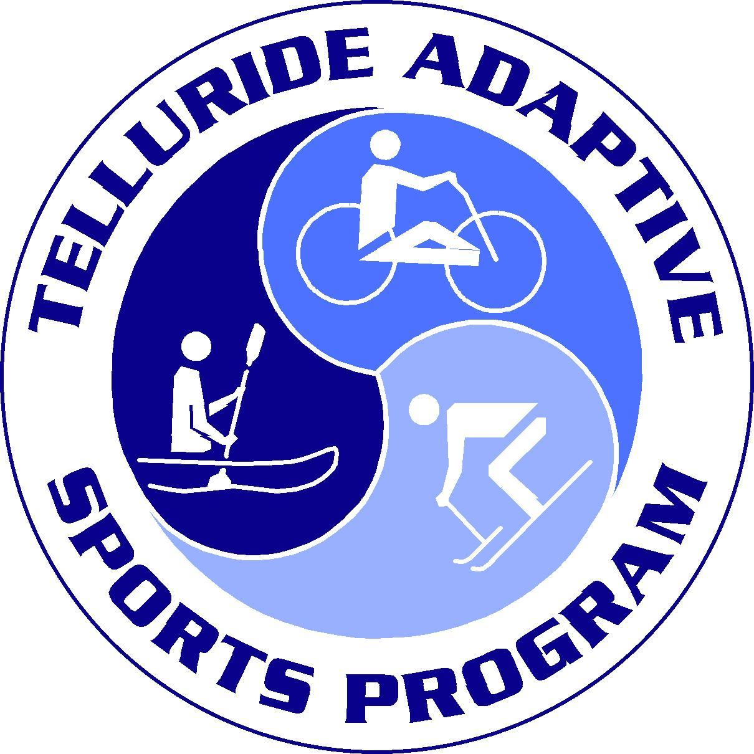

Media Contact: Courtney Stuecheli
970-729-1163
director@tellurideadaptivesports.org

Telluride Adaptive Sports Hosts Special Screening of Film Full Circle

Telluride Adaptive Sports Program (TASP) hosts a special screening of the film Full Circle on Thursday, December 28 at 5:30 PM at the Telluride Palm Theatre. The community is invited to gather and experience the compelling and inspiring, ski adventure film with all proceeds benefiting TASP. Tickets are $10 in advance and $15 at the door and can be purchased on the TASP website https://www.tellurideadaptivesports.org/event/full-circle-fundraiser/

In 2014, Trevor Kennison's life was forever altered by a broken back sustained in the backcountry of Colorado. FULL CIRCLE is both an unblinking examination of the challenges of life after a spinal cord injury, and a celebration of the opportunity for adventure and growth that such a tragedy can present. In 2019, Trevor showed up as an unknown amateur in Jackson Hole Wyoming, and became the first sit-skier to launch Corbet’s Couloir at the Kings and Queens of Corbet’s competition. His death-defying 60-foot leap of faith went viral and launched his career as a professional athlete. More importantly, it earned him a spiritual mentor, Barry Corbet—the famous skier and mountaineer for whom the iconic couloir at Jackson Hole is named after many decades earlier. Both men were paralyzed from the waist down, but neither one gave up on the sport they loved. In fact, both rose to become leaders and role models in the disability community.

Full Circle is an adventure ski film, following the parallel stories of Corbet and Kennison. It’s a story of redemption and perseverance. Both men refused to let their condition hinder their passion for skiing. This new film explores the challenges behind their stories and celebrates the growth that came out of their tragedies. Full Circle is 104 minutes long and appropriate for adults and teens (not for young children).

The film has been generously sponsored by Ellison MacIntire Partners and the Garrett Companies.

Telluride Adaptive Sports Program (TASP) is a non-profit organization dedicated to enriching the lives of people with disabilities by providing therapeutic recreational opportunities that develop life skills and encourage personal growth. For more information or to get involved please contact TASP at 970-728-5010 our website at www.tellurideadaptivesports.org.

